Syeda Reeha Quasar

14114802719

4C7

Aim

Write a program to read the class object of student info such as name, age, sex, height and weight from the keyboard and to store them on a specified file using read () and write () functions. Again, the same file is opened for reading and displaying the contents of the file on the screen.

Experiment - 18

Object Oriented Programming Lab

# **EXPERIMENT – 18**

## **Aim:**

Write a program to read the class object of student info such as name, age, sex, height and weight from the keyboard and to store them on a specified file using read () and write () functions. Again, the same file is opened for reading and displaying the contents of the file on the screen.

## **Source Code:**

#include <iostream>

using namespace std;

class basic_info

{

    char name[10], sex;

    int rollno;

public:

    void getdata()

    {

        cout << "Enter rollno,name and sex : ";

        cin >> rollno >> name >> sex;

    }

    void display()

    {

        cout << "Name: " << name << "\nRoll no. :" << rollno << "\nSex: " << sex;

    }

};

class physical_fit : public basic_info

{

    float height, weight;

public:

    void getdata()

    {

        basic_info::getdata();

        cout << "Enter height and weight ";

        cin >> height >> weight;

    }

    void display()

    {

        basic_info::display();

        cout << "Height :" << height;

        cout << "\nWeight :" << weight;

    }

};

int main()

{

    physical_fit p;

    p.getdata();

    p.display();

    return 0;

}

## **Output:**

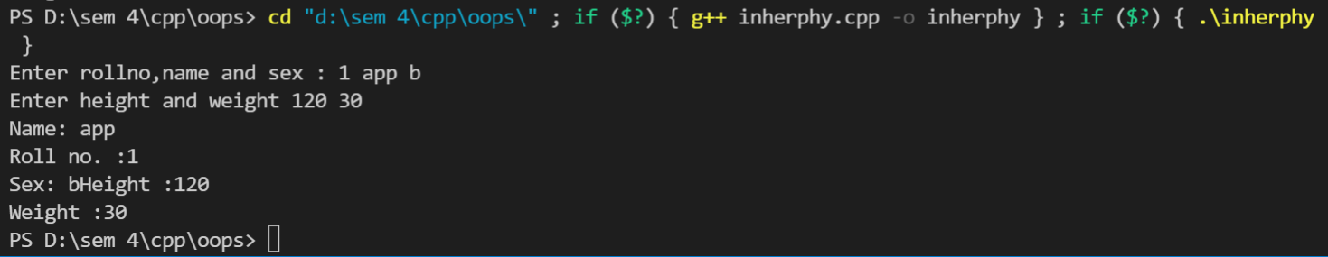

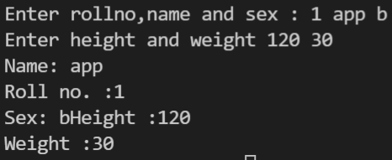

# **Viva Questions**

#### Q1) What is inheritance?

Ans.

Inheritance is one of the feature of Object Oriented Programming System(OOPs), it allows the child class to acquire the properties (the data members) and functionality (the member functions) of parent class.

*Q2) What is child class?*

*Ans.*

*A class that inherits another class is known as child class, it is also known as derived class or subclass.*

*Q3) What is parent class?*

*Ans.*

*The class that is being inherited by other class is known as parent class, super class or base class.*

### Q4) What are the advantages of using inheritance in C++ Programming?

Ans.

The main advantages of inheritance are code reusability and readability. When child class inherits the properties and functionality of parent class, we need not to write the same code again in child class. This makes it easier to reuse the code, makes us write the less code and the code becomes much more readable.

Q5) What are advantages and disadvantages of inheritance?

Ans.

Disadvantages: -

* Inherited functions work slower than normal function as there is indirection.
* Improper use of inheritance may lead to wrong solutions.
* Often, data members in the base class are left unused which may lead to memory wastage.
* Inheritance increases the coupling between base class and derived class. A change in base class will affect all the child classes.

Advantages:

* Inheritance promotes reusability. When a class inherits or derives another class, it can access all the functionality of inherited class.
* Reusability enhanced reliability. The base class code will be already tested and debugged.
* As the existing code is reused, it leads to less development and maintenance costs.
* Inheritance makes the sub classes follow a standard interface.
* Inheritance helps to reduce code redundancy and supports code extensibility.
* Inheritance facilitates creation of class libraries.